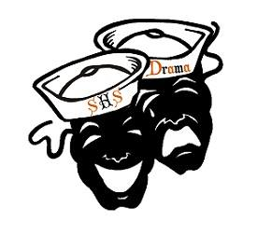

Sarasota High School Association of Dramatic Arts Boosters, Inc.
Wednesday September 18th, 2019

Welcome
- Treasurer report
- Booster fee - $10.00
- Teacher welcome
  - Introductions

- Website
  - www.shstheatre.com
    - Classes and afterschool information
    - Buy tickets
    - How to navigate the booster page/volunteer info
- Facebook
  - Join the SHS Theatre page
    - SHS Theatre Public page and our private page as well
      - Please like our Public page and give us a 5 star rating
- Remind 101
  - Parent boosters, text @shsada1920 to 81010

- Fall Show
  - Show T-shirts
    - $15.00
    - Order due TONIGHT.
  - Production Contract
    - Production Fee: $75
    - Due : September 25
    - After Carrabbas, Mrs. K will have an update list of who owes what
  - General information
  - TICKETS ARE ON SALE! Buy your tickets now to pick your seats and to create a ticket rush.
  - Possible advertising opportunities, publicity committee
  - Set Construction
    - 9/21 , 10/12 , 10/19
    - Supplies donations
    - Props list
  - Show Dates :
    - 12/11 – 12/13 @ 7:00pm
    - 12/14 @ 2:00 pm and 7:00 pm
- Fundraising
  - Ad Sales: Cast requirement, $50, due October 23
  - T-shirts/magnets/bumper stickers interest

- Holiday Gala
  - We will be performing at the SHS Holiday Gala on December 17

- Holiday Parade
  - Theme – Holidays By the Sea
  - There will be limited space so we will wait and see how many can attend. Choir members expected to perform that day will not be able to attend.
  - We are in need of candy canes. We hand these out to the kids in the streets as the float drives by.

- Volunteer registration
  - Every person who is around the kids must have a background check
  - Please sign up as Sarasota County School volunteers website (see handout)

- Sign-Up.com
  - How to sign up
    - Construction
    - Show meals
    - Publicity Committee
    - Pick Up/Errand Team
    - Gift Card Donation
    - Fundraising Committee
    - Costume Alterations/Sewing
    - Concession Workers
    - Costume Measurement
- Improv
  - First Show
    - September 25th @ 7:00 pm
      - Mission Improvable!
- Rehearsal schedules and due dates (found in production contracts)
- Meeting adjourned

