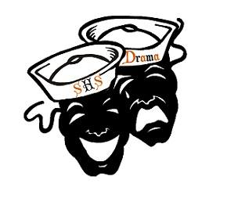

Sarasota High School Association of Dramatic Arts Boosters, Inc.
Wednesday - September 1, 2021

Welcome
- 2021-2022 Board - vote
- Treasurer report
- Booster fee - $10.00
- Ms. K - welcome
- Website
  - www.shstheater.com
    - Classes and afterschool information
    - Buy tickets
    - Pay show fees / t-shirt fees
    - How to navigate the booster page/volunteer info

- Facebook
  - Join the SHS Theatre page
    - SHS Theatre Public page and our private page as well
      - Please like our Public page
      - Please share events through our Facebook page- this will concentrate all social media traffic to one place and make our posts more visible

- Sign-Up.com
    - How to sign up
      - Construction, Gift Card Donation, Costume Alterations/Sewing, etc.

- The Lion, The Witch, and the Wardrobe
  - Set construction
  - Fees
  - Show dates – October 13-15
  - Meals for kids

- I Never Saw Another Butterfly
  - Set construction
  - Fees
  - Show dates – January 26-28
  - Meals for kids

- Dinner Theater Experience: The Underdogs
  - February 26th

- Footloose
  - Show dates – April 20-23

- Holiday Parade – 12/4

- Possible Disney trip
  - discussion

- Sponsorship

- Meeting adjourned

