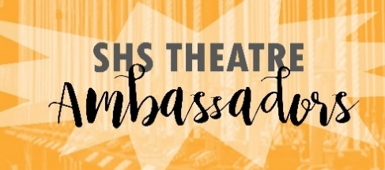

TENTATIVE SCHEDULE 2022-2023
These are the dates for all events we know of. Other events will likely be added to the schedule, and we will try our best to notify you of those as soon as possible. Check the website for staffing assignments.
All dates are subject to change.

SEPTEMBER
Thursday the 15TH- Improv Show

OCTOBER
Tuesday the 4th- Band/Orchestra Concert
Tuesday the 11th- Jazz Concert
Wednesday the 26th- NHS Inductions

NOVEMBER
Wednesday the 9th- Veteran’s Day Concert Rehearsal
Thursday the 10th- Veteran’s day Concert

DECEMBER
Tuesday the 13th- Band Concert
Wednesday the 14th- Gala Rehearsal
Tuesday the 20th- Improv Show

FEBRUARY
Thursday the 2nd- Mr. Sarasota Rehearsal
Friday the 3rd- Mr. Sarasota
Tuesday the 21st- Band Concert
Saturday the 25th- Broadway Dinner Theater
Tuesday the 28th- Choir concert

MARCH
Wednesday the 1st- Miss SRQ Rehearsal
Thursday the 2nd- Miss SRQ
Thursday the 9th- Improv Show

APRIL
Monday the 26th- MAST Symposium
Friday the 28th- Sweet Jazz

MAY
Tuesday the 2nd- Band Concert
Thursday the 4th- JROTC Awards
Saturday the 6th- Choir Cabaret (off campus)
Tuesday the 9th- Sailor Symphony Concert

